**CAR COMBAT GAME**

Lucas Krespi dos Santos

Julian Escobar Echeverri

George Brown College

CNR – 12515: Game Production 3

Instructor: Daniel Posner

September 30, 2020

Contents

1.INTRODUCTION 3

2.GAME ELEMENTS 3

2.1.Turrets 3

2.2.Hazards 3

2.3.Boost 5

2.4.Player 5

2.5.Map 5

Figure Table

Figure 1-Enemy Turret 3

Figure 2 - Slow Hazard 4

Figure 3 - Damage Hazard 4

Figure 4 - Kill Hazard 4

Figure 5 - Boost 5

Figure 6 - player car 5

Figure 7 - Map Prototype 6

# INTRODUCTION

This Game is a single player car combat game, where the player is on a dungeon like level and has to destroy enemy turrets in order to win the game, there is a total of 12 turrets placed on the map, this turrets will shoot projectiles to try to destroy the player car. The car is going to have two guns to shoot back at the enemies. The level will have some boosts and hazards, the hazards cause damage, slow or both depending on the type, and the boosts will push the car forward fast.

# GAME ELEMENTS

## Turrets

Enemy turrets will shoot projectiles that deal damage to the player.

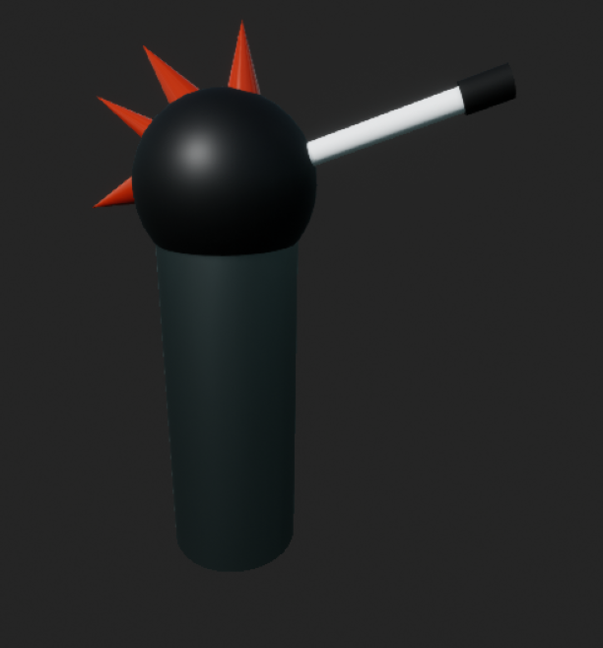

Figure 1-Enemy Turret

## Hazards

We have 3 types if hazards, the first one causes a slow on the player, the second one deals damage, and the third destroys the player, they are just a tile on de ground with a different light on top to differ the type.

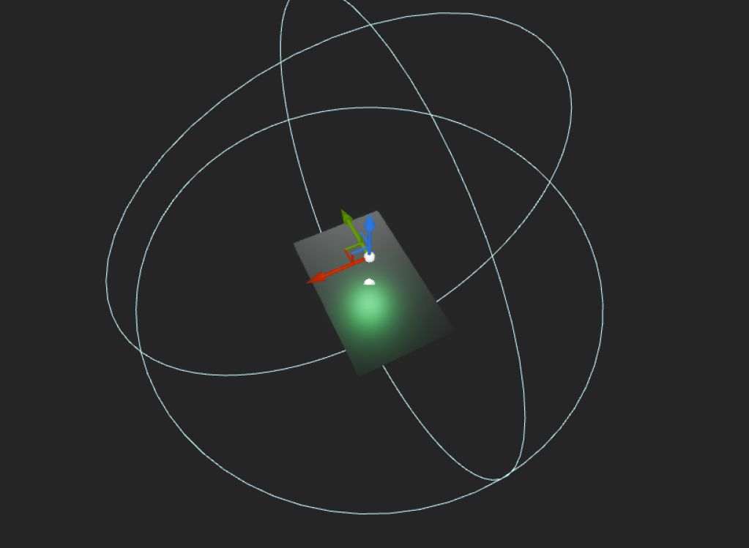

Figure 2 - Slow Hazard

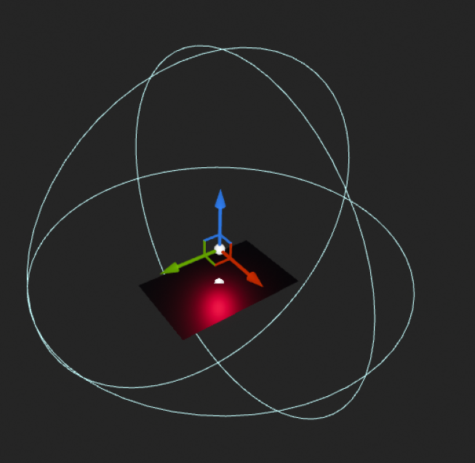

Figure 3 - Damage Hazard

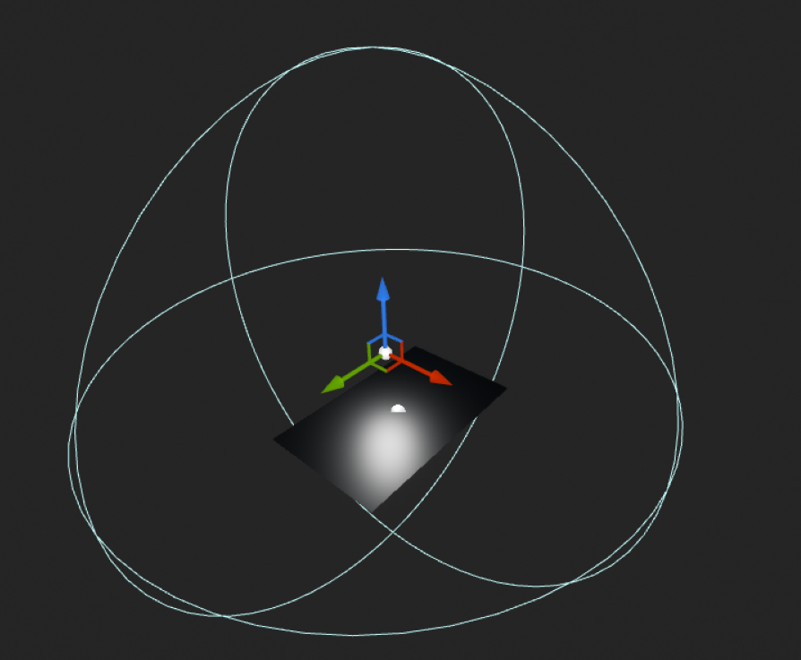

Figure 4 - Kill Hazard

## Boost

Boost will be placed just before the ramps and will increase the car speed by 70 km/h more than the original speed.

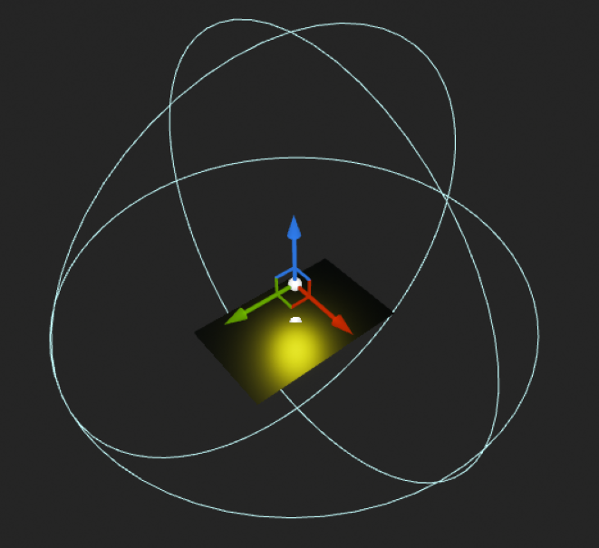

Figure 5 - Boost

## Player

For now, the player car is the unreal default car model. But in the future, it is going to be changed for and asset with guns, that can shoot, and a life bar. The car can move with WASD keys and is affected by the hazards and boosts.

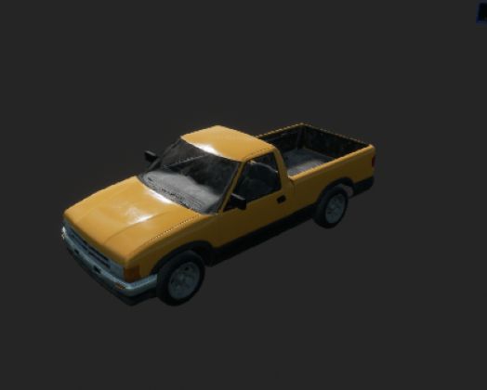

Figure 6 - player car

## Map

The Map will be a dungeon like with all the elements listed above, where the player can move between the edges, every other asset will be stationary.

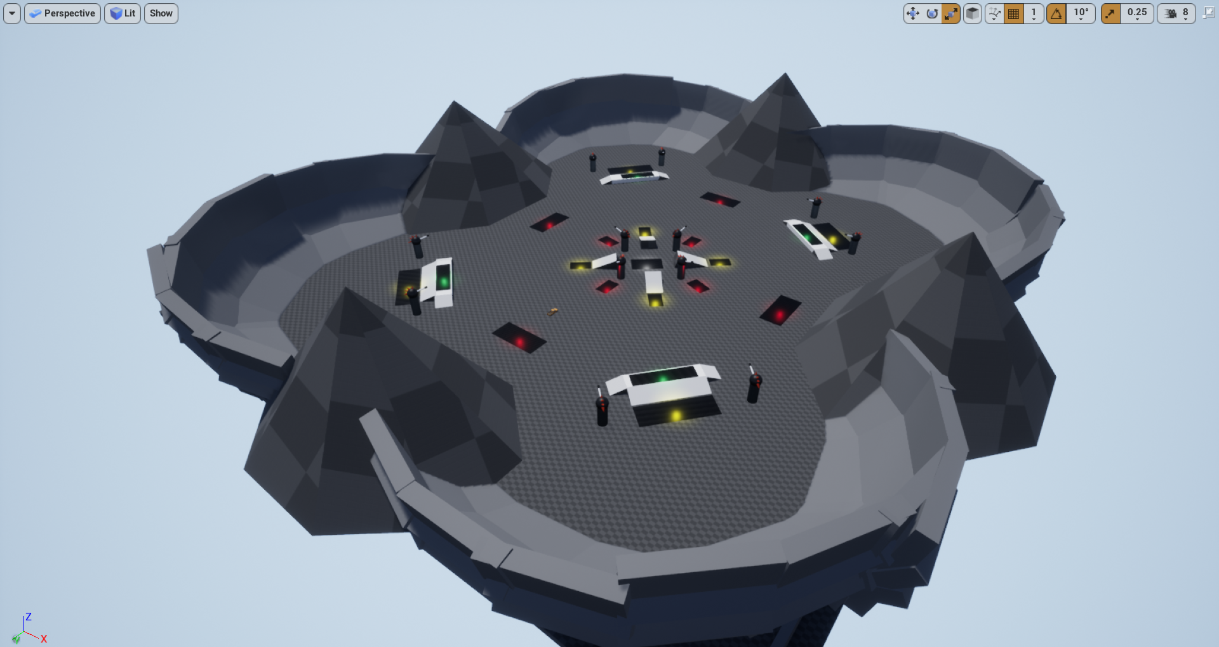

Figure 7 - Map Prototype